**THE REPORT PREPARED BY TRANSPORTGAS SRBIJA DOO NOVI SAD**

**ON THE DEFINITION AND IMPLEMENTATION OF INTERIM MEASURES**

January 2025

Contents

Introduction 3

1. Description of the status of development and liquidity of the short-term wholesale natural gas market at the moment of preparing the Report 4

А) Phase of development and liquidity of the short-term natural gas market 5

2. The proposal for interim measures to be implemented 8

3. Reasons to implement interim measures 9

4. Time frame and definition of steps to suspend the implementation of the interim measure 10

Conclusion: 10

# Introduction

The Government of the Republic of Serbia, pursuant to Article 93а paragraph 1 item 4) sub-item (4) of the Law on Energy (“Official Gazette of RS” no. 145/14, 95/18 - other law, 40/21, 35/23 - other law, 62/23 and 94/24), and in relation to the Treaty establishing Energy Community between the European Commission and the Republic of Albania, Republic of Bulgaria, Bosnia and Herzegovina, Republic of Croatia, Former Yugoslav Republic of Macedonia, Republic of Montenegro, Romania, Republic of Serbia and the United Nations Interim Administration Mission in Kosovo pursuant to the United Nations Security Council Resolution 1244 (“Official Gazette of RS” no. 62/06) and Article 17 paragraph 1, and Article 42 paragraph 1 of the Law on Government (“Official Gazette of RS” No. 55/05, 71/05 - correction, 101/07, 65/08, 16/11, 68/12 - CC, 72/12, 7/14 - CC, 44/14, and 30/18 – other law), has adopted the Regulation on Network-related Rules for Balancing the Natural Gas Transmission System published in the “Official Gazette of RS” no. 112 dated 12 October 2022 (hereinafter referred to as the Regulation).

Among other matters, this Regulation includes rules and measures related to operational balancing of the transmission system, daily allocations for transportation users, daily imbalance charges, and provision of information by the Transmission System Operator (TSO).

The Regulation’s objective is to establish rules and measures that would contribute to improved competitiveness and liquidity in the short-term wholesale natural gas market.

According to Article 44 of the Regulation, “If the short-term wholesale natural gas market is not sufficiently liquid, Transmission System Operator shall apply the proper interim measures from Articles 46 to 49 of this Regulation”.

Articles 44 and 47 of the Regulation stipulate that TSO may implement the interim measures. In order to implement the interim measures, Transportgas Srbija doo is submitting this Report on Interim Measures, so that the Energy Agency of the Republic of Serbia could approve it.

The submitted Report contains the description and overview of the current situation in the natural gas market in Serbia, the proposed interim measures and reasons for their implementation, as well as incentives and actions Transportgas Srbija doo Novi Sad should implement in order to terminate the implementation of interim measures.

# 1. Description of the status of development and liquidity of the short-term wholesale natural gas market at the moment of preparing the Report

Transportgas Srbija doo Novi Sad is the Transmission System Operator for natural gas in the territory of the Republic of Serbia. Natural gas is transmitted to the consumers from the following entry points:

* At the Hungary/Serbia border, entry point U1 Horgoš, Gas Transmission System Operator FGSZ, physical flow of natural gas is only possible in the direction Hungary - Serbia;
* At the Bulgaria/Serbia border, entry point U2 Kalotina/Dimitrovgrad, Gas Transmission System Operator Bulgartrans, current physical flow of natural gas is in the direction from Bulgaria;
* Entry point from another transmission system in the country IP Srbija, Gas Transmission System Operator Gastrans, physical flow of natural gas is in the direction from the transmission system Gastrans;
* From the underground gas storage Banatski Dvor, and
* From locally produced gas.

In the gas year 2023/2024, the percentages by sources of supply were as follows:

Table 1

|  |  |  |
| --- | --- | --- |
| No. | Type of supply | Percentage |
| 1 | Imported natural gas | 85.69 |
| 2 | Storage | 8.33 |
| 3 | Local production | 5.98 |

In 2003, the wholesale natural gas market was based on trade between natural gas suppliers and producers. In 2023, only one supplier and one producer sold natural gas to other suppliers in this market, and only one supplier for public suppliers sold natural gas to all public suppliers.

The following table includes data related to entry and exit quantities to/from the transmission system of Transportgas Srbija doo Novi Sad in the previous three gas years:

Table 2

|  |  |  |  |  |
| --- | --- | --- | --- | --- |
| Gas year | | 2021/2022 | 2022/2023 | 2023/2024 |
| Gas quantities at the entry point to the transmission system | kWh | 36,185,773,810 | 34,090,358,592 | 30,481,072,743 |
| Gas quantities at the exit point from the transmission system | kWh | 36,165,008,996 | 34,106,213,530 | 30,400,582,310 |

As a natural gas Transmission System Operator, Transportgas Srbija doo Novi Sad is responsible for physical and commercial system balancing.

Physical balancing is conducted through a series of activities by which the TSO ensures the efficient operation of the transmission system in real time, organising the transportation of natural gas from the entry points to the exit points of the transmission system at all times. Considering that the gas market in Serbia is relatively small, for the purpose of balancing the transmission system, the TSO uses balancing services and partially line pack, as there is no balancing platform in place in accordance with the Regulation.

Transportgas Srbija doo Novi Sad procures balancing services through a process compliant with public procurement regulations to ensure transparency and non-discrimination. This means that there is “openness”, or the possibility for all suppliers to sign a contract under which Transportgas Srbija doo Novi Sad purchases and also sells natural gas for system balancing purposes.

In the previous period, in response to the public call for the procurement of natural gas for system balancing purposes, only one bidder applied.

The TSO’s obligations regarding informing system users, which Transportgas Srbija doo Novi Sad currently fulfils in accordance with the Regulation, include the following:

* Transportgas Srbija doo Novi Sad has enabled access to data on the Operational Platform, where each system user can view information on the total quantities of natural gas transported, on an hourly and daily basis, at each entry and exit point where capacity is acquired;
* Providing data on measured flows monthly, broken down by days;
* Providing data on the daily initial, final, and calculated imbalance at the end of the gas month.

## А) Phase of development and liquidity of the short-term natural gas market

The following table shows the number of concluded transactions and the total number of transactions at the Virtual Trading Point, as well as the quantities from purchase offers and sales offers.

Table 3

|  |  |
| --- | --- |
| Number of transactions performed at VTP | 0 |
| Total number of transactions | 0 |
| Amount of purchase and sales | Total balancing amount  529 million kWh in the gas year 2023/2024 |

In the gas year 2023/2024, there were 5 registered users of the transmission system and 3 users actively used the transmission system of Transportgas Srbija doo Novi Sad.

At the entry point U1 Horgoš for gas year 2023/2024, the capacity was used by one User, and at the entry point U2 Kalotina/Dimitrovgrad, the capacity was also used by one User.

At the entry points Locally Produced Gas for the gas year 2023/2024, the capacity was acquired by two Users.

At the entry point from the underground gas storage Banatski Dvor, the capacity was used by two Users, with the following percentages:

Chart 1

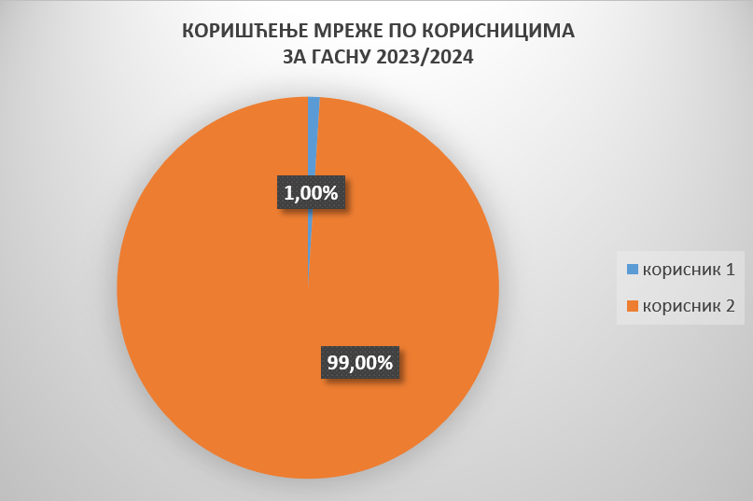

* **GAS USER 1**
* **GAS USER 2**

**UTILIZATION OF THE NETWORK BY GAS USERS FOR 2023/2024**

At the entry point IP Srbija, the capacity was used by two Users, with the following percentages:

Chart 2

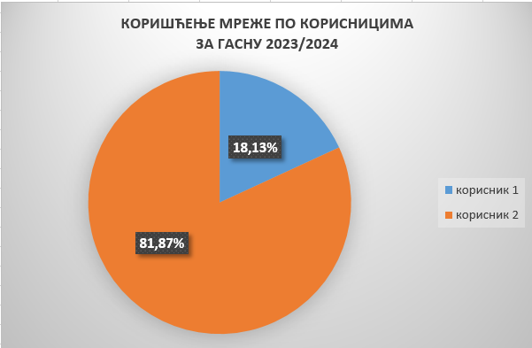

* **GAS USER 1**
* **GAS USER 2**

**UTILIZATION OF THE NETWORK BY GAS USERS FOR 2023/2024**

Since the current liquidity of the Serbian short-term wholesale gas market is very low (Table 3), and there is no system balancing platform, Transportgas Srbija doo Novi Sad uses Balancing Services stipulated by the Regulation.

Charts 3 and 4 present the ratio of the use of capacities at the transmission system for three Users in the last two gas years:

Chart 3

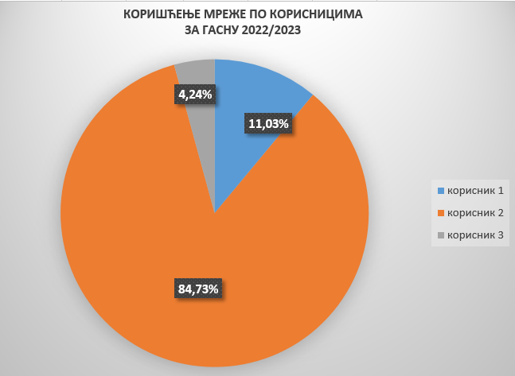

**UTILIZATION OF THE NETWORK BY GAS USERS FOR 2022/2023**

* **GAS USER 1**
* **GAS USER 2**
* **GAS USER 3**

Chart 4

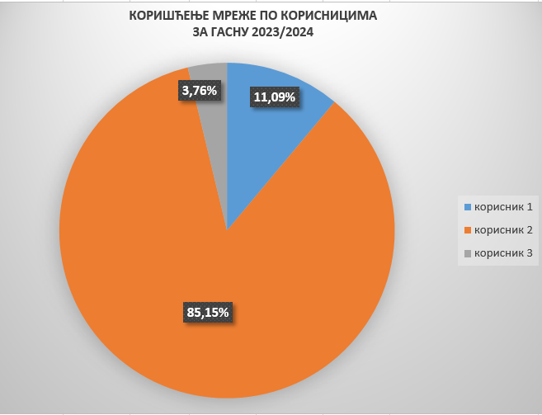

**UTILIZATION OF THE NETWORK BY GAS USERS FOR 2023/2024**

* **GAS USER 1**
* **GAS USER 2**
* **GAS USER 3**

The users of the natural gas transmission system managed by Transportgas Srbija doo Novi Sad which engage in wholesale activities as sellers of natural gas are only two companies.

The third User of the transmission system uses a part of the capacity of the natural gas transit network, by using the services of access to natural gas and its transportation through the territory of Serbia from the entry point IP Srbija to the exit point TI Loznica at the border with BiH, and to store natural gas in the underground gas storage Banatski Dvor.

# 2. The proposal for interim measures to be implemented

Transportgas Srbija doo Novi Sad proposes the implementation of the following interim measures for approval:

* Balancing Platform;
* Balancing services.

Transportgas Srbija doo Novi Sad currently does not have a Balancing Platform that would make it possible for the TSO to perform effective balancing activities.

Transportgas Srbija doo Novi Sad plans to procure and implement a Balancing Platform at the earliest possible date, and no later than 30 April 2027, as it is expected that this temporary measure will contribute to increasing the liquidity of the short-term wholesale natural gas market.

Until the Balancing Platform is procured and implemented, the use of the temporary measure of balancing services is anticipated, which is already being practically applied in Transportgas Srbija doo Novi Sad.

Balancing services are the services of selling natural gas to the TSO or purchasing natural gas from the TSO based on the Balancing Services Agreement, when the TSO needs to buy or sell natural gas to balance the transmission system.

The balancing services are procured in a process compliant with public procurement regulations to

ensure transparency and non-discrimination.

The Balancing Services Agreement is signed for a maximum period of one year.

As a result of implementing this temporary measure, an imbalance fee will be applied for imbalance calculation.

Procedure for determining a User’s imbalance:

At the end of the gas month, the TSO calculates the final daily imbalance quantity for each User by subtracting the final exits from their final entries for each gas day.

When a User has a negative final daily imbalance quantity, an amount will be calculated that the User owes for that gas day, based on the daily imbalance quantities priced at the rate Transportgas Srbija doo Novi Sad pays to purchase natural gas for balancing purposes. When a User has a positive final daily imbalance quantity, Transportgas Srbija doo Novi Sad is obligated to pay the User an amount for that gas day, based on the daily imbalance quantities priced at the rate Transportgas Srbija doo Novi Sad sells natural gas for balancing purposes.

# 3. Reasons to implement interim measures

Considering the low liquidity of the Serbian market, as evidenced by point 1 of this Report, it is necessary to introduce interim measures.

According to Article 8 of the Regulation:

“The Transmission System Operator may contract balancing services to be provided to them when short-term standard products cannot, or are unlikely to, adequately ensure that the transmission system remains within its operational limits, as well as in cases of insufficient liquidity in trading short-term standard products.”

Currently, balancing services are the primary mechanism by which Transportgas Srbija doo Novi Sad, as the TSO, can fulfil its obligation to safely balance the transmission system.

In this regard, Transportgas Srbija doo Novi Sad will procure balancing services through a process compliant with public procurement regulations to ensure transparency and non-discrimination. At the same time, since a public procurement process is conducted, all suppliers have the opportunity to sign contracts based on which Transportgas Srbija doo Novi Sad purchases and sells natural gas for system balancing purposes, thereby ensuring competition among suppliers for signing contracts with the TSO. Since imbalance calculation is accompanied by the calculation of imbalance fees for Users, based on prices arising from the balancing services contracts, it is expected that suppliers will be motivated to trade with each other to reduce these costs. Namely, Users have the opportunity to trade natural gas quantities with each other at the VTP during the gas day to balance their daily portfolio, which subsequently reduces the needs of Transportgas Srbija doo Novi Sad to undertake balancing actions.

# 4. Time frame and definition of steps to suspend the implementation of the temporary measure

The proposed temporary measure stems from the state of liquidity in the natural gas market of the Republic of Serbia.

It is estimated that the time required for the termination of the temporary measure of balancing services will be the maximum period allowed - 5 years from the date the Regulation enters into force.

During this period, Transportgas Srbija doo Novi Sad will submit reports once a year in accordance with the Regulation.

To terminate the interim measures, the following steps are planned to take place between 2025 and 2030, contributing to increased short-term market liquidity:

* Adoption and implementation of the Transportgas Srbija doo Novi Sad Rules of Operation aligned with the Regulation - transparent and non-discriminatory Rules are envisaged, under which network users will be responsible for balancing their balancing portfolios. The Rules will include imbalance fees reflecting balancing costs in the absence of market prices and introduce a neutrality fee as a form of financial settlement;
* Introduction of a new short-term standard capacity product—intraday capacity product in line with the Rules of Operation to be adopted, which will make it possible for the suppliers to quickly respond by buying and selling natural gas, and effectively balance their balancing portfolios. This will facilitate an increase in the number of transactions, potential growth in the number of users, and more efficient system balancing for Transportgas Srbija doo Novi Sad, which could also impact the market.
* Activities for preparing the Balancing Platform and transitioning to a Gas Trading Platform.
* Integration of the Serbian gas market into the regional market.

# Conclusion:

Taking in consideration the above, i.e. how the short-term wholesale natural gas market is not developed, i.e. not liquid enough, the temporary measure is proposed to establish a Balancing Platform.

Since Transportgas Srbija doo Novi Sad has not yet established the Balancing Platform, this Report is submitted to the Energy Agency of the Republic of Serbia for approval, so that Transportgas Srbija doo Novi Sad could arrange for implementation of balancing services in their Rules of Operation, in accordance with the Article 47 of the Regulation, as the only possible alternative balancing measure.